/\*\*

\* Q 1) Write a program to demonstrate Java Swing components such as

\* JPasswordField,

\* JCheckbox,

\* JTextField,

\* JList

\* JRadioButton.

\*

\*/

import javax.swing.\*;

public class javaSwing{

public static void main(String[] args) {

JFrame f=new JFrame("javaSwing");

JPasswordField passwordField = new JPasswordField();

JLabel labelPassword=new JLabel("Password:");

JLabel labelUsername=new JLabel("Username:");

JTextField usernameField=new JTextField();

JCheckBox checkBox=new JCheckBox("Check Box");

JRadioButton radioButton=new JRadioButton("Radio Button");

String week[]= { "Monday","Tuesday","Wednesday", "Thursday","Friday","Saturday","Sunday"};

JList list=new JList(week);

labelUsername.setBounds(20,60,80,30);

usernameField.setBounds(100,60,100,30);

labelPassword.setBounds(20,100, 80,30);

passwordField.setBounds(100,100,100,30);

checkBox.setBounds(30,140,100,30);

radioButton.setBounds(30,180,120,30);

list.setBounds(30,240,400,150);

f.add(labelUsername); f.add(usernameField);

f.add(passwordField); f.add(labelPassword);

f.add(checkBox);

f.add(radioButton);

f.add(list);

f.setSize(500,500);

f.setLayout(null);

f.setVisible(true);

}

}

Output:

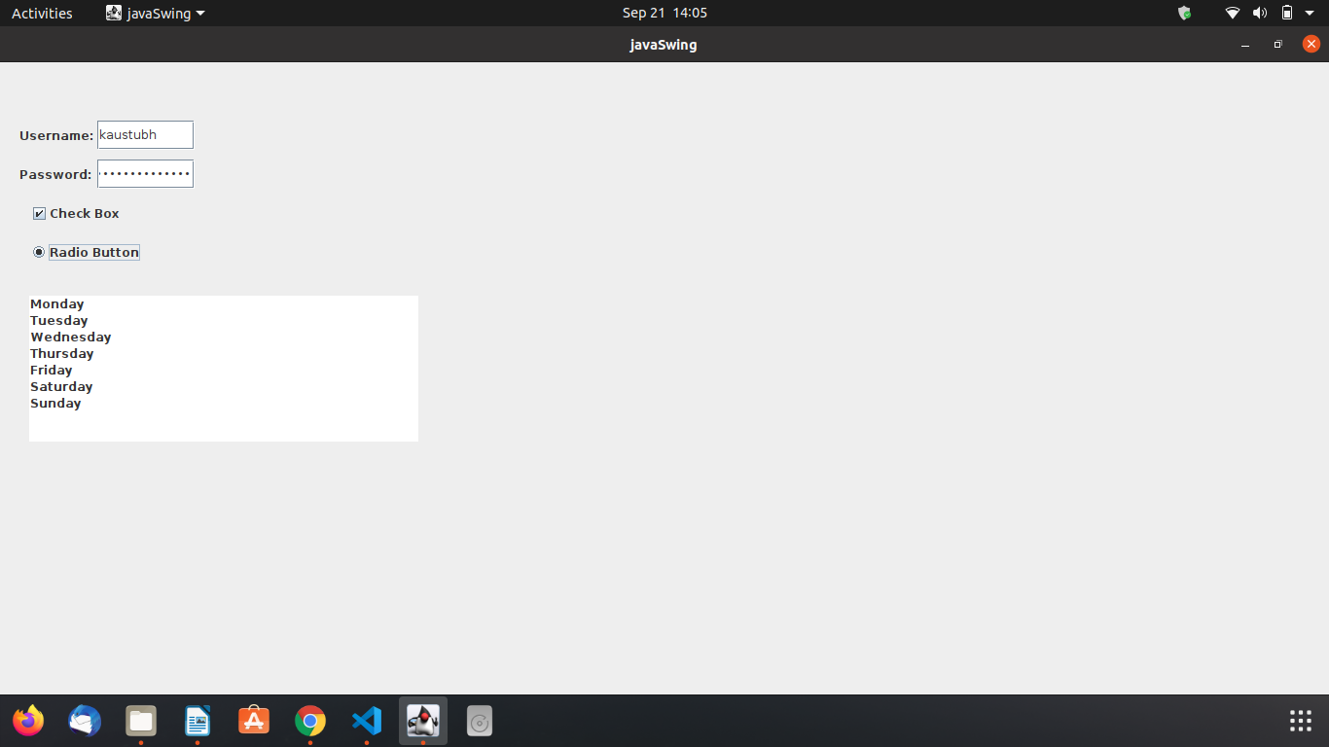

P.T.O.

/\*\*

\* Q 2) Write a java program to display Progress Bar.

\*/

import javax.swing.\*;

public class progressbar {

public static void main(String[] args) {

JFrame f = new JFrame("ProgressBar ");

JPanel panel = new JPanel();

JProgressBar progressBar = new JProgressBar(0, 20);

progressBar.setValue(0);

progressBar.setStringPainted(true);

panel.add(progressBar);

f.add(panel);

f.setSize(500, 500);

f.setVisible(true);

try {

Thread.sleep(2000);

} catch (InterruptedException e) {

// TODO Auto-generated catch block

e.printStackTrace();

}

progressBar.setValue(100);

}

}

Output:

